BACHELOR OF SCIENCE IN ARTIFICIAL INTELLIGENCE
Group B · 4th Semester · Subject: Software Engineering
Assignment No. 1
Process Model Selection for a
University Timetable Optimization & Management System
Submitted by: Muhammad Hammad Shakeel
Instructor: Sajid Anwar
Department of Information and Technology

SECTION 1

Introduction
Before any team writes a single line of code, before anyone draws a single flowchart, there is one decision that quietly shapes everything that follows — the choice of a process model. It determines how requirements are gathered, how risks are faced, how developers iterate, how stakeholders give feedback, and ultimately whether the final product looks anything like what was originally imagined.
This assignment explores that foundational decision for a specific project: a University Timetable Optimization and Management System. The system is intended to automate the preparation, review, and publication of academic schedules across multiple departments, teachers, student groups, and physical rooms — eliminating the manual, error-prone, spreadsheet-driven timetabling that most universities still endure today.
The goal of this report is not simply to pick a model and move on. The goal is to examine the nature of the project carefully, understand what each candidate process model offers and what it costs, and then make a reasoned, justified choice that any reader — whether a professor or a future developer on the team — could look at and say, "Yes, that makes sense for this kind of project."
A process model is not a bureaucratic formality. It is the architecture of how a team thinks and works. Choosing the wrong one can doom a project as surely as a wrong algorithm or a broken database schema.

SECTION 2

Project Overview
The University Timetable Optimization and Management System is a web-based application built for academic institutions. At its core, the system must do two distinct things that are harder to combine than they might appear at first glance: manage master data, and generate feasible schedules from that data.
On the management side, the system must handle records for departments, semesters, courses, sections, student groups, teachers, rooms, and time slots. Administrators need to configure teacher availability, room capacities, blocked days, holidays, and institutional policy preferences. All of this is fairly standard information management work.
On the optimization side, the system must take that data and produce timetables that avoid direct scheduling conflicts — two teachers in the same room, a section scheduled in two places at once, a teacher assigned during their declared unavailability — while simultaneously trying to satisfy softer preferences like compact student schedules, morning-heavy timetabling during summer terms, and spatial proximity for rooms used in consecutive sessions.
The expected users of the system span five roles: the Timetable Administrator who controls the entire process, the Department Coordinator who oversees academic unit requirements, the Teacher who submits availability and views their own schedule, the Student who accesses published timetables, and the Facility Manager who tracks room usage.
This combination — non-trivial data management, algorithmic scheduling, multi-role interaction, and evolving institutional policies — makes the project genuinely complex. It is not a homework CRUD application. It demands a development process mature enough to handle that complexity without collapsing under its own weight.

SECTION 3

Requirements Characterization
To choose a process model rationally, it is necessary to first understand what kind of requirements this project carries. Not all software projects are alike. The nature of the requirements — how stable they are, how well-understood they are, how visual they need to be — has a direct bearing on which process model will serve the team best.

What Is Known from the Start
Certain things about the timetable system are clear before development begins. Every academic institution knows its basic entities: teachers have names and availability, rooms have capacities, courses meet a certain number of times per week, and schedules must not produce clashes. These hard constraints can be specified early and with confidence.What Tends to Emerge Later
There is another category of requirement that shows up in nearly every timetable project: the preferences and edge cases that nobody mentions until they see a draft schedule and react to it. A department head might say they did not realize they wanted third-year courses scheduled before noon. A teacher might submit a change request revealing a missing system rule. This pattern of early clarity on structure and late discovery of nuanced preferences is almost universal in scheduling software.

Visual Validation Is Essential
Timetable systems are inherently visual products. A schedule is not meaningful as a database table — it becomes meaningful when it is laid out in a grid and a human being can look at it and say, "This looks reasonable" or "This makes no sense." That means early user feedback on screen design and workflow layout is genuinely important, not just a nice-to-have.

The Project Has Natural Phases
The system can be broken into logical layers: first the master data, then the rule configuration, then the generation engine, then the review-and-repair workflow, then publication and reporting. These layers depend on each other in a clear sequence. That structural decomposition suggests that phased development is a natural fit for this project.

SECTION 4

Candidate Process Models
Four well-established software development process models were considered. Each is described below along with a diagram illustrating how it structures the development lifecycle.

The Waterfall Model
The Waterfall Model is the classic sequential development lifecycle, first formalized by Royce in 1970. It divides development into distinct, non-overlapping phases: Requirements, System Design, Implementation, Testing, Deployment, and Maintenance. Each phase must be fully completed and signed off before the next one begins — like water flowing downhill, it moves in only one direction.
Waterfall is most powerful when requirements are exceptionally stable and well-understood at the outset. Where it struggles is precisely where most real-world software ends up: when user needs evolve, when stakeholders change their minds after seeing a working prototype, or when the project domain contains hidden complexity that only surfaces during implementation.
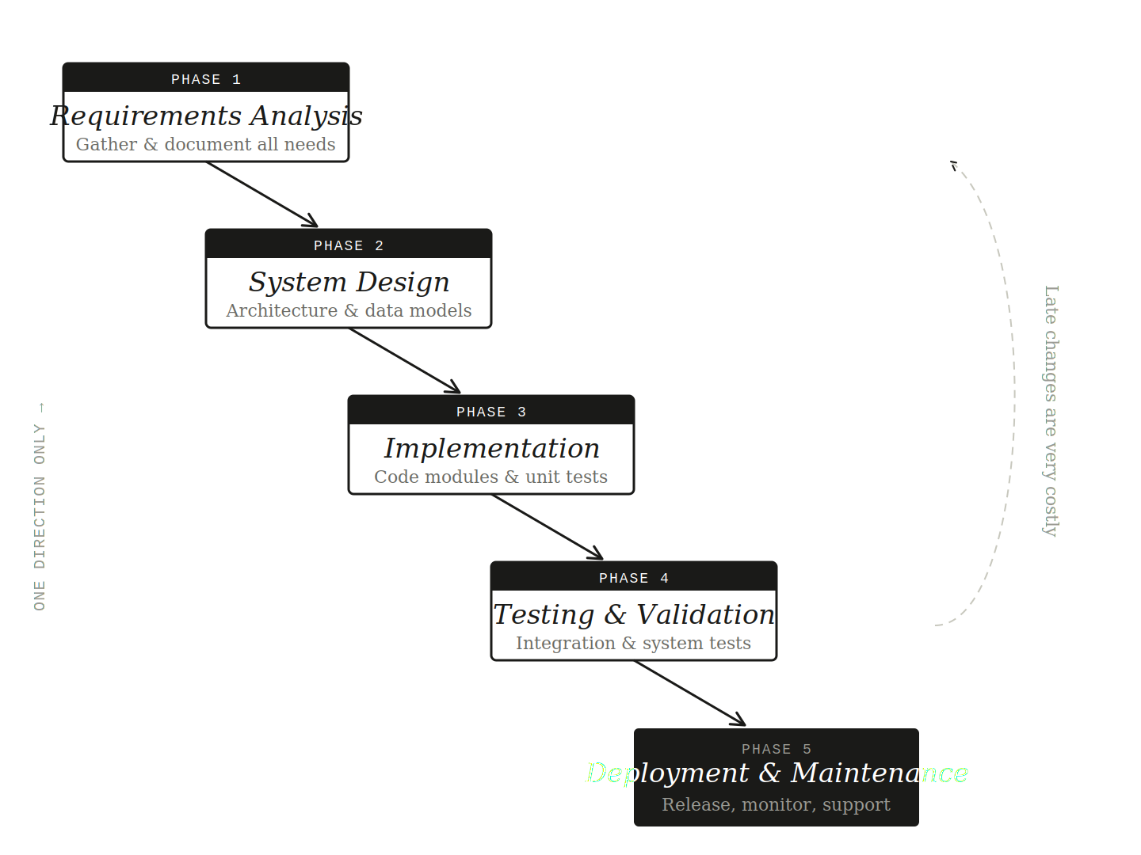
Figure 1 — The Waterfall Model: sequential, phase-locked, one-way flow

The Incremental Model
The Incremental Model decomposes development into a series of smaller, self-contained releases, each of which adds a defined chunk of functionality to what was built before. Rather than trying to deliver the entire system at once, the team makes a series of deliveries — each one working software that can be reviewed, tested, and built upon.
Each increment follows a mini-lifecycle of its own: analysis, design, code, and test, applied to that increment's scope. The system grows progressively, and stakeholders can interact with working versions of the product throughout development, not just at the end. This early and continuous feedback loop is one of the model's most valuable properties.
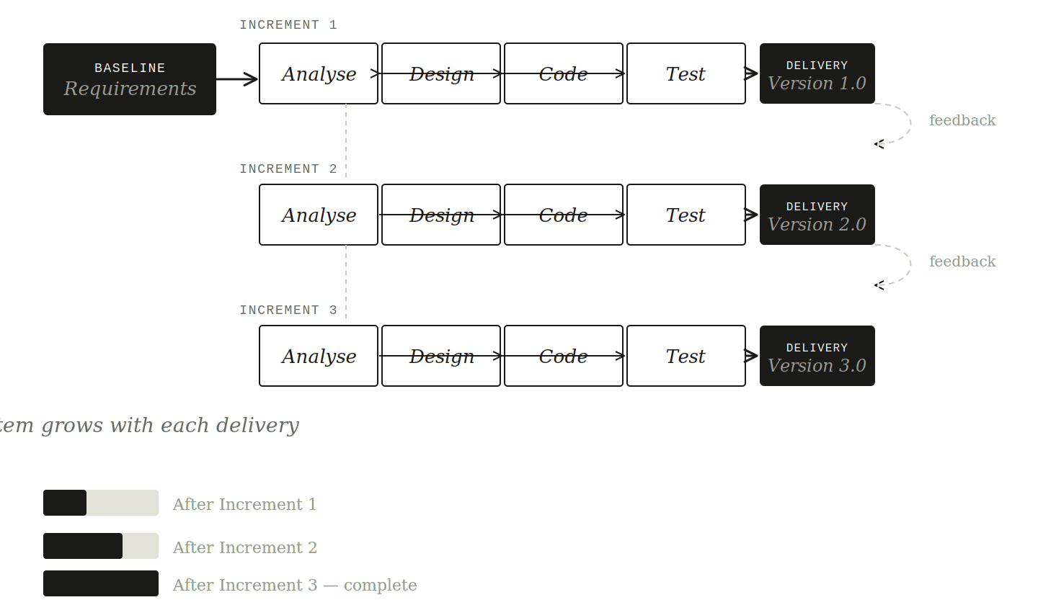
Figure 2 — The Incremental Model: structured phases repeated for each delivery

The Spiral Model
Proposed by Barry Boehm in 1986, the Spiral Model is a risk-driven development lifecycle organized around repeated cycles of planning, risk assessment, engineering, and evaluation. It does not separate these activities into distinct sequential phases. Instead, it revisits all of them in every cycle, with the project growing more concrete and the risks becoming smaller with each rotation outward from the center.
The model is particularly well-suited to large, high-stakes projects where technical uncertainty is significant. Its emphasis on risk identification at every stage means that dangerous assumptions get surfaced and dealt with early. For a university project on a semester timeline, however, its procedural overhead can outweigh its benefits unless the project genuinely has the critical risk profile that justifies full spiral discipline.
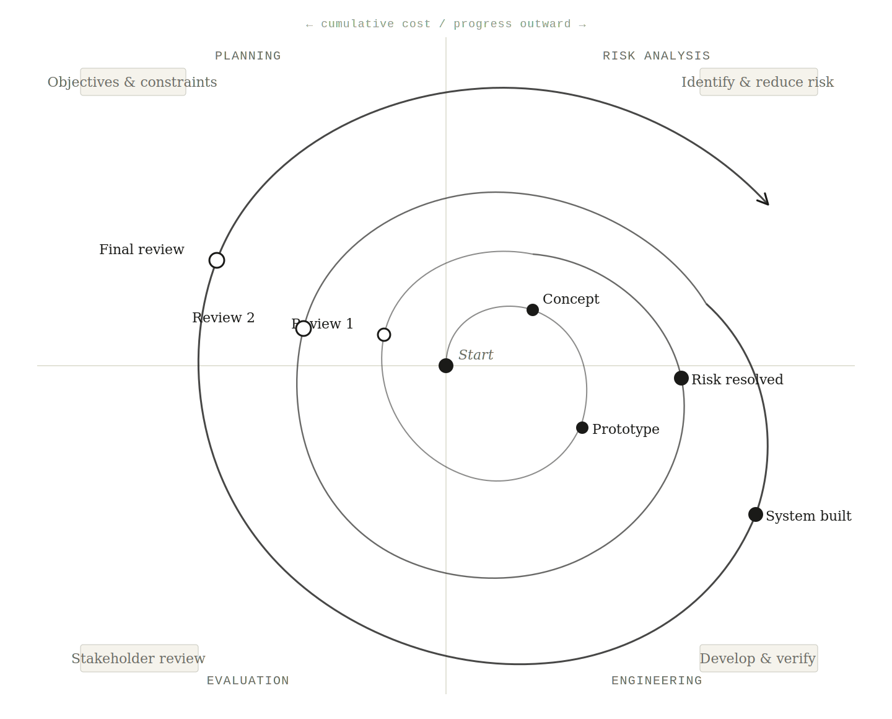
Figure 3 — The Spiral Model (Boehm, 1986): risk-driven, outward-growing cycles

Agile / XP Practices
Agile software development is not a single model but a family of methodologies sharing a common philosophy: deliver working software early and often, respond to changing requirements rather than fighting them, and prioritize human collaboration over comprehensive documentation. Extreme Programming (XP) is one specific Agile method emphasizing pair programming, test-driven development, continuous integration, and very short release cycles.
Agile methods are extraordinary in environments where requirements are highly volatile and constant user interaction is possible. However, they require tight stakeholder collaboration that is not always available in academic project contexts, and they can feel underdisciplined when a course assignment demands formal documented outputs. Agile practices work better as tactical tools inside a more formally structured process than as the primary lifecycle model.
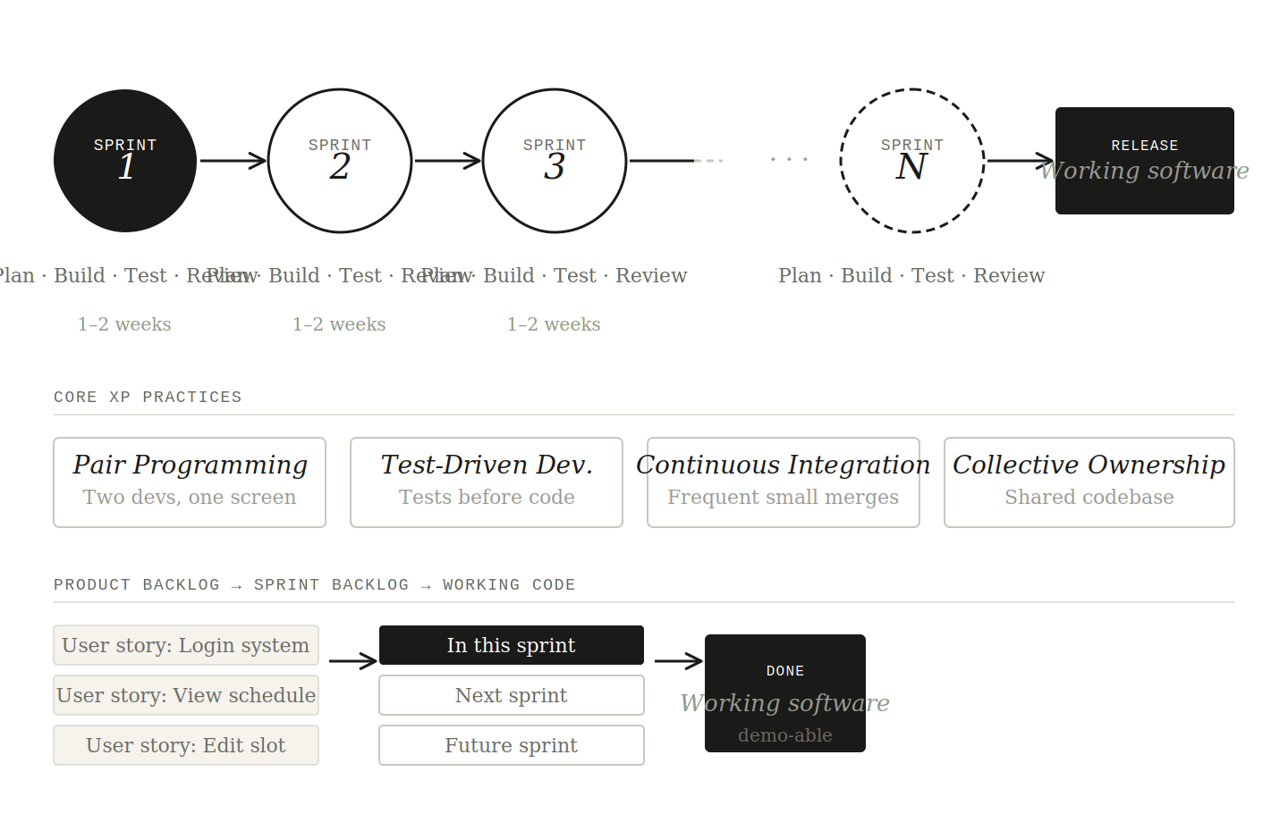
Figure 4 — Agile / XP: short iterative sprints, continuous delivery, backlog-driven

SECTION 5

5. Selection Criteria
Choosing between candidate models requires more than intuition. The following criteria were defined based on the characteristics of this specific project:
- Requirement volatility: How likely are requirements to change after development begins? A project with evolving requirements needs a model that accommodates change without treating it as failure.
- Project complexity: Does the system do more than store and retrieve data? Higher complexity — like algorithmic scheduling and constraint processing — favors staged development.
- Need for visual validation: Do stakeholders need to see working screens and timetable layouts early, rather than just reading requirement documents?
- Technical risk: Are there areas where the right technical approach is uncertain? The scheduling engine carries real implementation risk.
- Documentation requirements: This is an academic project. It must produce formal documentation at each stage, not just working software.
- Phased deliverability: Can the project be broken into meaningful, independently testable pieces? This reduces the all-or-nothing risk of a single end-of-semester submission.
- Testing feasibility: Can different parts of the system be tested independently, or must everything come together before any meaningful testing is possible?

SECTION 6

6. Comparative Evaluation
The four candidate models were scored against each criterion on a scale of 1 (poor fit) to 5 (excellent fit). Weights reflect each criterion's relative importance to this project. The Incremental Model column is highlighted as it emerges as the strongest overall fit.

Criterion | Wt. | Waterfall | Incremental ✓ | Spiral | Agile/XP
Requirement volatility handling | 5 | 2 | 5 | 5 | 5
Modular development suitability | 4 | 3 | 5 | 4 | 4
Early feedback & prototype support | 4 | 2 | 5 | 5 | 5
Risk handling | 4 | 2 | 4 | 5 | 4
Documentation suitability | 3 | 5 | 4 | 4 | 3
Semester project practicality | 5 | 3 | 5 | 2 | 4
Ease of testing in stages | 4 | 2 | 5 | 4 | 4
Fit for timetable refinement | 5 | 2 | 5 | 4 | 4
WEIGHTED TOTAL | — | 72 | 107 | 100 | 99

The matrix reveals a clear winner in the Incremental Model, which scores highest on the criteria that matter most: requirement volatility handling, modular development, timetable refinement support, and semester practicality. The Spiral Model is a close second on technical dimensions but falls behind on practicality. Agile/XP scores well on adaptability but loses points on documentation suitability.

SECTION 7

7. Selected Process Model
Selected Primary Model: Incremental Process Model — Early prototyping is used as a supporting validation technique within initial increments, not as a separate co-equal lifecycle.
The Incremental Process Model has been selected as the primary development lifecycle for this project. This is not a default choice — it is the result of comparing the specific characteristics of a university timetable system against what each model offers.
One important distinction must be stated clearly: prototyping is not selected as a co-equal lifecycle model. Instead, prototype-quality screens and workflows will be built during early increments specifically to validate user interface decisions and surface hidden requirements. Once that validation is complete, development proceeds on firm incremental footing. Prototyping is a technique used within the lifecycle, not the lifecycle itself.

SECTION 8

8. Justification of the Selected Model

8.1 Requirements Are Practically Guaranteed to Evolve
There is a well-known pattern in timetable software development: the first time a stakeholder sees a generated schedule, they discover requirements they did not know they had. Maybe it is a preference for keeping consecutive classes in nearby rooms. Maybe it is a department rule about not scheduling core courses on Fridays. In this kind of project, requirement evolution is not a failure of analysis — it is a structural property of the domain. Any process model that treats late requirement changes as exceptional and costly is the wrong model.

8.2 The System Has Genuine Depth
The scheduling part — generating conflict-free timetables while satisfying soft preferences — is a constrained optimization problem with non-trivial behavior. Rule interactions can produce unexpected outcomes. Score functions behave differently across different data configurations. The system can produce technically valid schedules that nonetheless feel wrong to users. This kind of depth is best approached layer by layer, not all at once.

8.3 Visual Feedback Is Not Optional
The single most important user-facing output of this system is a visual timetable grid. The difference between a good timetable interface and a bad one is something users can recognize immediately but may struggle to articulate upfront. Early prototypes of the schedule view, conflict inspection panel, and change-request workflow are not luxury features — they are how the team learns what the system actually needs to feel like to the people using it.

8.4 The Project Decomposes Naturally
One of the strongest arguments for an incremental approach is that this particular project falls apart into a natural sequence of layers. You genuinely cannot build the scheduling engine before you have the master data. You genuinely cannot build the review workflow before you have something to review. The dependency chain between components reflects the domain's actual logic. This means the incremental model is not just philosophically appropriate — it is structurally aligned with how the project actually needs to be built.

8.5 Testing Becomes Manageable
When a project is built incrementally, testing can be applied to each delivery as it is completed. Data validation rules can be tested before the scheduling engine exists. The scheduling engine can be tested before the publication workflow is built. This staged testing approach means that by the time the system is complete, most of it has already been tested in isolation. The alternative — testing everything at the end — creates enormous integration risk against an academic semester deadline.

8.6 It Supports Future Algorithmic Refinement
The selection of the core scheduling algorithm — whether constraint propagation, simulated annealing, or a hybrid approach — is a decision that benefits from having the surrounding system already working. When the web application, data model, and rule-configuration workflow are in place, the team can experiment with different generation strategies without destabilizing the rest of the system. An incremental model makes this possible; Waterfall would force that decision far too early.

8.7 It Is More Suitable Than Waterfall
Waterfall assumes requirements can be completely captured before design begins, that design can be finished before implementation begins, and that implementation can be done before testing begins. In a timetable system where stakeholder preferences surface gradually through iterative draft reviews, that assumption is simply untrue. The cost of late changes in a Waterfall process is high, and late discovery of requirements is not an accident in this domain — it is expected behavior.

8.8 It Is More Practical Than Spiral
The Spiral Model would be genuinely excellent for a large, mission-critical timetabling system being deployed across a national university network with significant regulatory requirements. But for a semester-scale academic project, the procedural overhead of full spiral discipline creates more process than the project needs. The timetable system has real risks, but they are manageable through good incremental planning without the full weight of a spiral framework.

SECTION 9

9. Why Other Models Were Not Selected

9.1 Waterfall: The Wrong Shape for This Problem
Waterfall was not selected because this project is likely to experience refinement after stakeholders inspect early timetable drafts. The project also requires visual validation and policy adjustment, which reduce the suitability of a rigid linear lifecycle. Waterfall would delay useful feedback and make later rule changes more expensive to incorporate.

9.2 Spiral: Powerful but Disproportionate
Spiral was not selected as the primary model because, although it handles risk exceptionally well, it introduces more planning overhead than necessary for a software engineering subject project. The timetable system contains meaningful risk, but it is manageable through staged increments and early validation without the full formal risk-analysis overhead of a true spiral process.

9.3 Agile/XP: Good Tactics, Wrong Primary Frame
Agile and XP practices are attractive because they support adaptation and frequent feedback. However, this assignment also requires formal reporting and structured documentation at each stage. Agile practices may inform the implementation style during development, but they are not the best primary framing for an academic process-model selection that expects clear lifecycle documentation. Agile practices will support the team; they will not govern the formal process model.

SECTION 10

10. Proposed Increment Plan
The following roadmap translates the selected model into a concrete sequence of deliveries. Each increment is designed to be independently reviewable, buildable, and testable. The sequence respects the natural dependency structure of the system while ensuring that something meaningful is working and demonstrable at each stage.

# | Increment Title | Scope & Description
01 | Academic Structure & Resource Setup | Departments, semesters, courses, sections, teachers, rooms, and time slots. This is the foundational data layer — the entity model with proper validations, relationships, and admin screens.
02 | Constraint & Policy Configuration | Teacher availability windows, room suitability flags, blocked days, holidays, and preference settings. Early prototyping of these screens provides the primary visual validation phase.
03 | Core Timetable Generation (MVP) | The initial scheduling engine producing a conflict-free timetable from configured data. Hard-constraint validation and a basic conflict view. Correctness matters more than optimality at this stage.
04 | Review, Repair & Controlled Re-optimization | Draft timetable inspection, manual change request handling, conflict explanation panels, and limited re-optimization after approved changes. The transition from generator to management tool.
05 | Publication, Filtered Views & Operational Reports | Final timetable publishing, role-based views for teachers and students, room utilization reports, export functionality, and holiday-aware display.

SECTION 11

11. Process Model Lifecycle Diagram
The diagram below illustrates the complete Incremental Model lifecycle as applied to this project. It shows the baseline requirements phase, the sequence of five increments with their internal mini-cycles, the prototyping activity confined to early increments, and the continuous documentation and testing thread running alongside all development.
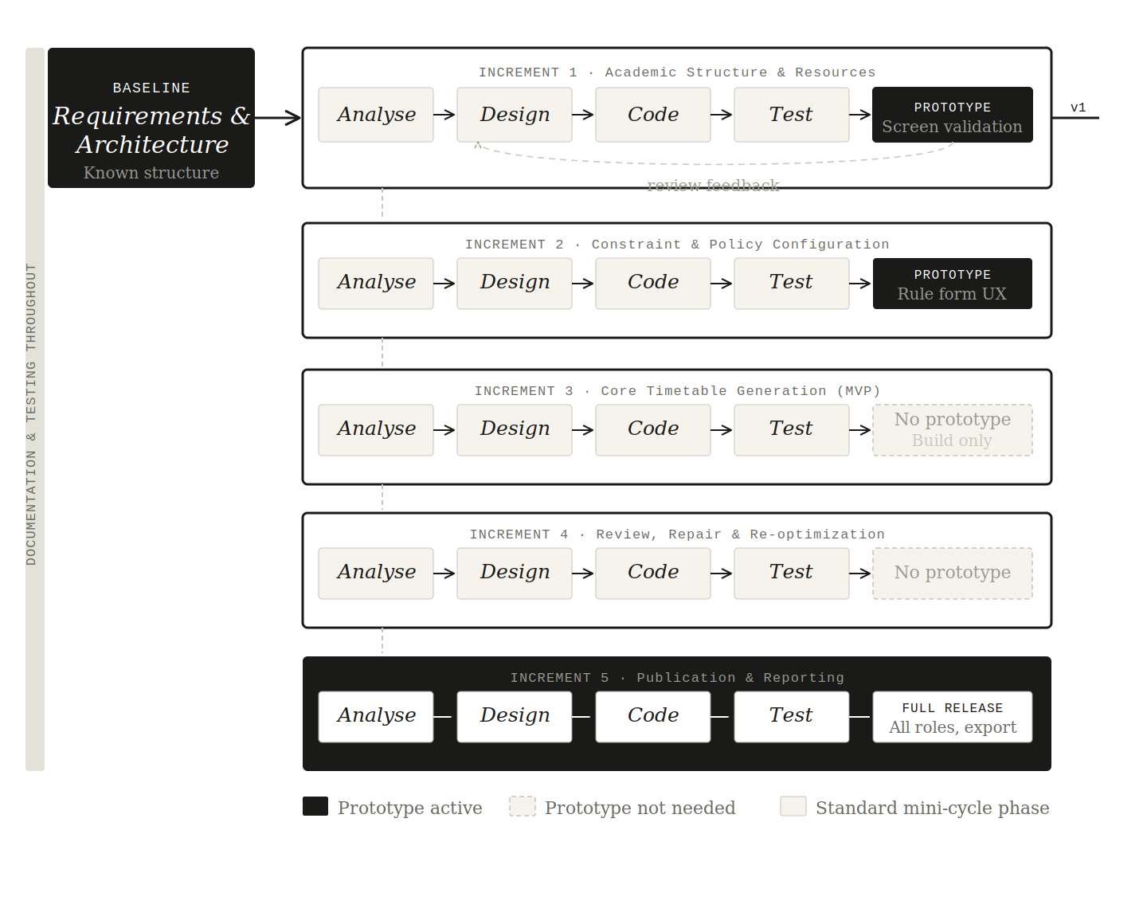
Figure 5 — Applied lifecycle: Incremental Model for the Timetable System (prototyping active only in increments 1–2)
The diagram confirms that Incremental is the primary lifecycle while prototyping remains a supporting validation technique used only where it genuinely reduces risk — in the first two increments where interface decisions and hidden preferences are most likely to surface.

SECTION 12

12. Conclusion
The process of selecting a development lifecycle model is, at its core, an act of matching. It is about looking honestly at what a project actually is — what it needs, where it will fail, what it does not yet know about itself — and finding a structure that fits those realities rather than forcing the project into a shape it does not naturally have.
For the University Timetable Optimization and Management System, the Incremental Process Model is that fit. The project will encounter requirement evolution — it is that kind of domain. The project has natural structural layers that benefit from sequential delivery. The project's users need to see working interfaces early. The project carries real technical risk in its scheduling engine that is better mitigated through staged development than through a single high-stakes integration at the end.
The Waterfall model would freeze requirements that cannot be frozen. The Spiral model would impose procedural overhead that the project does not need at its scale. Agile practices are valuable but are better positioned as implementation-level tactics than as the primary process framework for an academic assignment requiring structured deliverables.
The Incremental Model gives this project the flexibility to learn from its own development without losing the structure that makes that development documentable, testable, and academically defensible. That is the right combination for a project of this kind, at this scale, on this timeline.
Prototyping will be used in early increments to validate screens and surface hidden preferences, but it will not govern the lifecycle. Development will proceed one meaningful, reviewable layer at a time. The final result will be a system that was not just built, but grown — each increment making the next one clearer, more confident, and more correct.

REFERENCES

References

- Sommerville, I. Software Engineering, 10th edition. Pearson, 2015.
- Pressman, R. S. & Maxim, B. R. Software Engineering: A Practitioner's Approach, 8th edition. McGraw-Hill, 2014.
- Larman, C. Applying UML and Patterns: An Introduction to Object-Oriented Analysis and Design, 3rd edition. Prentice Hall, 2004.
- Boehm, B. W. "A Spiral Model of Software Development and Enhancement." IEEE Computer, 21(5), 61–72, 1988.
- Beck, K. Extreme Programming Explained: Embrace Change, 2nd edition. Addison-Wesley, 2004.
- Royce, W. W. "Managing the Development of Large Software Systems." Proceedings of IEEE WESCON, 1970.

